# BCIT

**Comp 3951 Special Topics in Application Development**

**Technical Programming Option**

# Option Head Mirela Gutica

Mark: ________ /100

Lab 5: Unit Tests

1. Read the documentation as per the links specified in the PP.
2. Create Unit Tests to test the functionality of the calculator and game library.
   1. Class examples (10p)
   2. Extra functionality (20p)
3. (70p) Identify functionality that is relevant to your project. Create a .dll including classes relevant to your project and unit tests including several methods to test functionality.
   1. Open Visual Studio and create a new C# Class Library project (.NET Framework)

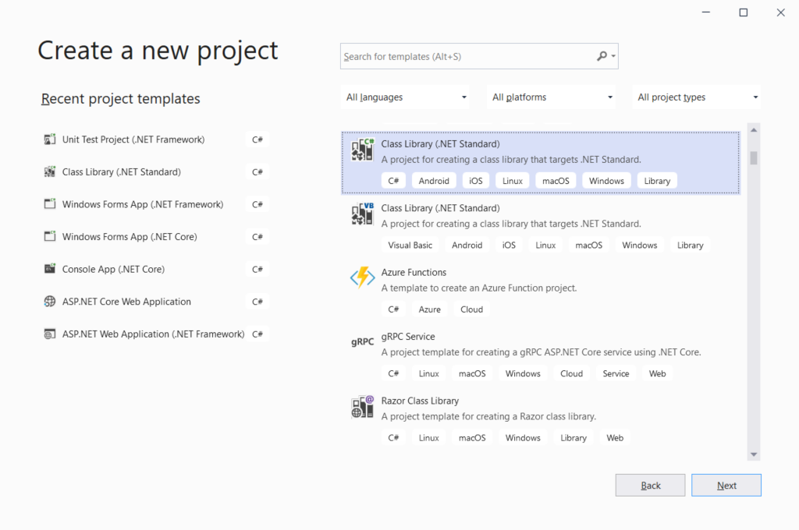

* 1. Rename Class1.cs to the name of your choice
  2. Implement the class: write code including properties, constructors, methods, etc.
  3. Create more classes as needed.
  4. Built the code and fix errors.
  5. Create the Unit Testing project in the same solution
     1. Right click on the solution, select Add, and select New Project…
     2. Make sure that the Unit Testing project matches the Project that you are testing (e.g., if you use .Net Core, select XUnit
     3. select the “Unit Test Project (.NET Framework)” type

The project is in the same solution with your class library

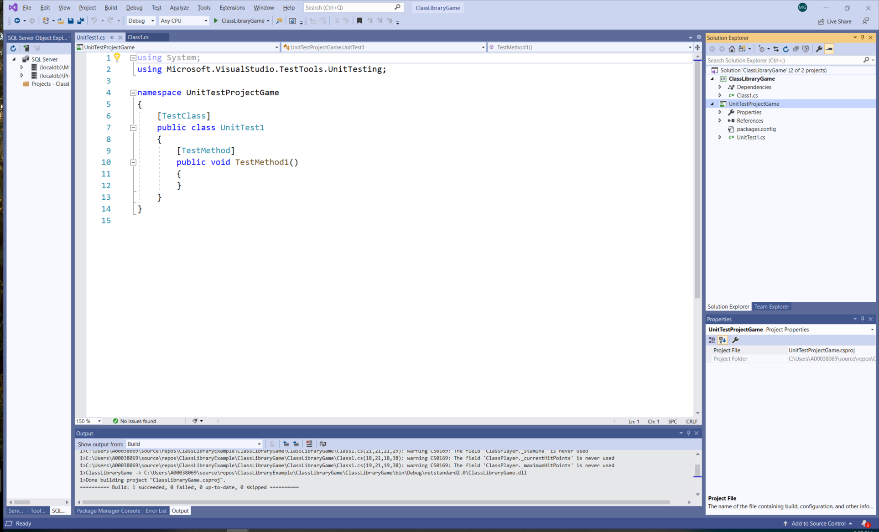

* + 1. add references to the class library
       1. right click on the UnitTest project and select Add, then select Reference, then select Project in the Reference Manager Window

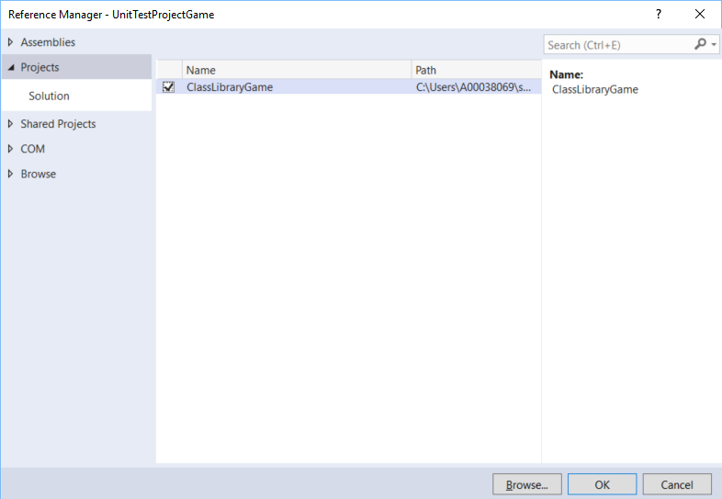

* 1. After the reference was added, make sure that you add the namespace using the “using” directive:

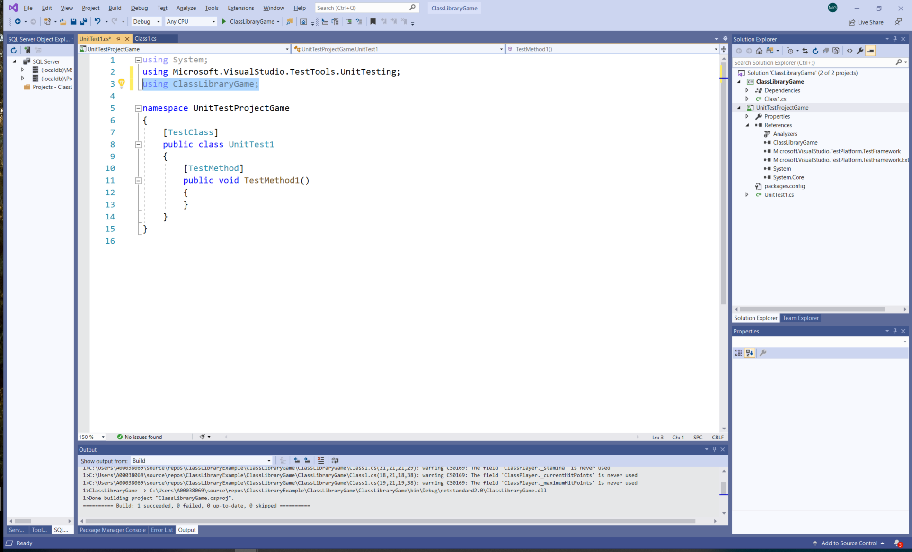

* 1. Write unit test methods; make sure that you include exceptions.
     1. Test
     2. Observe the results.

1. (10p) In a word document explain the functionality that you are testing and report your results.